

KELCO INDUSTRIES:
PROCESS FLOW DOCUMENT:
FIXED ASSET MANAGEMENT

Paapri Cloud Technologies
Fixed Asset System Setup
Log in to NetSuite using the Administrator role, and navigate to Fixed Assets-> Setup-> System Setup.
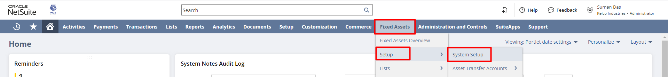

Under the General subtab, check the Post to Next Open Period if AP is Locked, Post to Next Open Period if AR is Locked and Allow Future-Dated Depreciation checkboxes, select the Summaries Journals By. Check all other fields if required.

Post to Next Open Period if AP is Locked: Check this box to allow posting to the next open period if AP is locked. Clear this box to allow posting to the current period even if AP is locked.

Post to Next Open Period if AR is Locked: Check this box to allow posting to the next open period if AR is locked. Clear this box to allow posting to the current period even if AR is locked.
Allow Future-Dated Depreciation: Check this box to permit depreciation of assets up to a depreciation date beyond that of the current period.
Allow Asset Value Editing: Check this box to give administrators full permission to edit values in asset records.
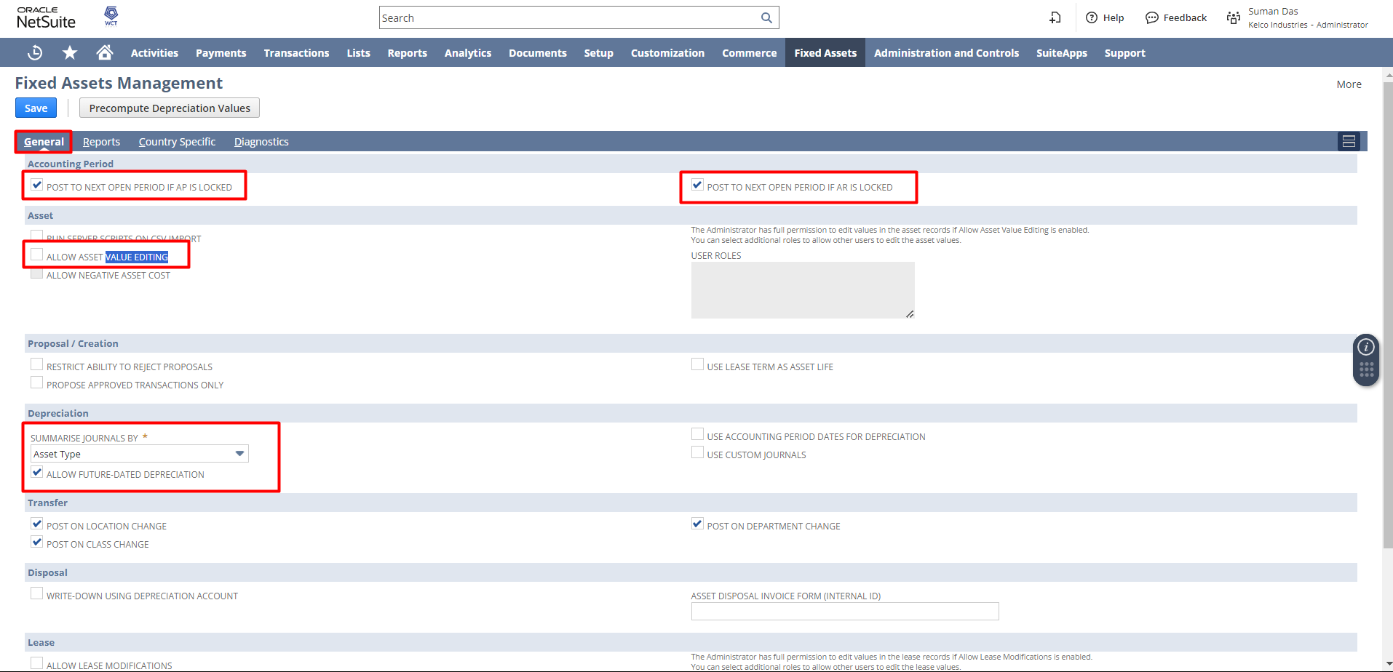

Under Reports subtab, enter the Internal ID of the folder in the file cabinet where Fixed Assets reports are saved. Check the Allow Administrators To View All Reports checkbox to allow administrators to view reports generated by other users. Click on the Save button.
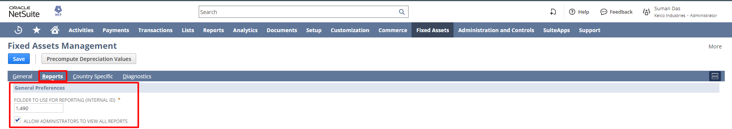
NOTE: The Precompute Depreciation Values button calculates the future depreciation for all the assets with active depreciation for the remaining asset lifetime until the asset reaches its Residual value.
This button does not create journals, you can use this button to have an overview of the depreciation amount that is going to be depreciated from the asset over a period of time.
Also, If the system detects record changes that will require an asset reset, the Reset Asset Values button will be visible on the System Setup page.
The Fixed Assets Management system records the changes to asset fields that are used in the depreciation formula, or affect the DHR data and summarization. When the reset process is triggered, the system deletes the forecast amounts for all affected records.
FAM Depreciation Method
Log in to NetSuite using the Controller role, and navigate to Fixed Assets-> Setup-> Depreciation Methods
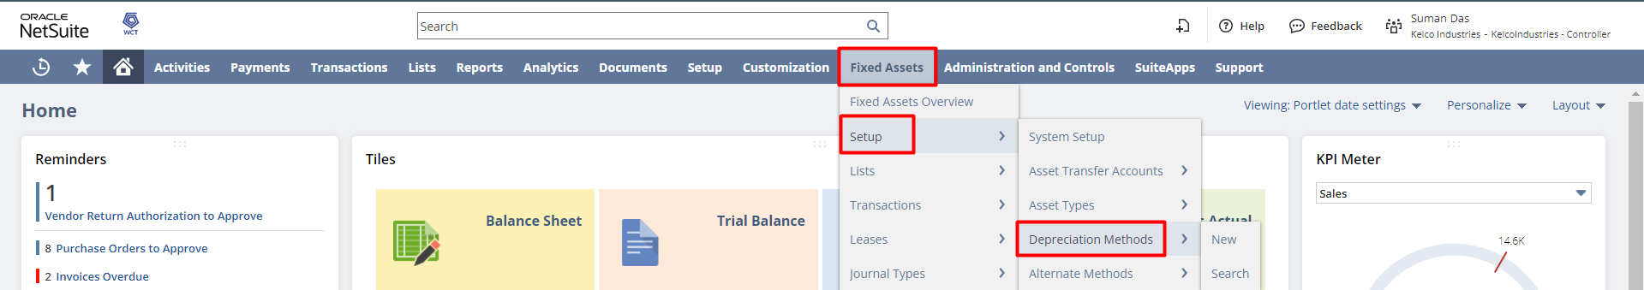
By default, a few depreciation methods are present in the system, the user can select any of them as per their requirement, Or, if the user wants to create based on their depreciation calculation, click on the New FAM Depreciation Method button.

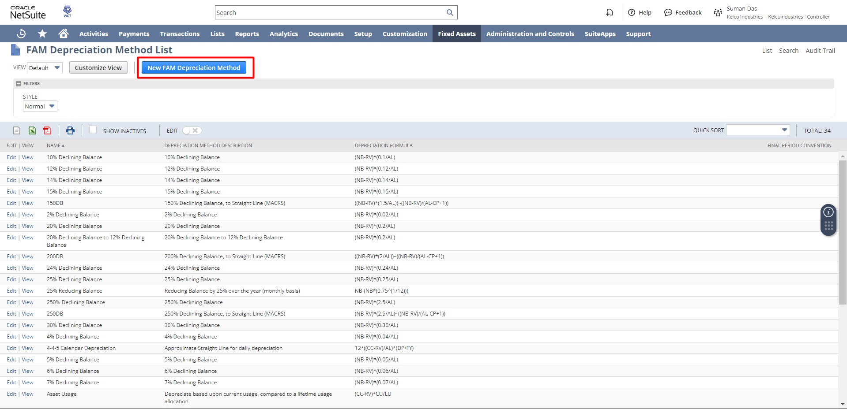
This is the form to create a new depreciation method, put Depreciation Method Name, Depreciation Method, Depreciation Formula to create your own depreciation method.
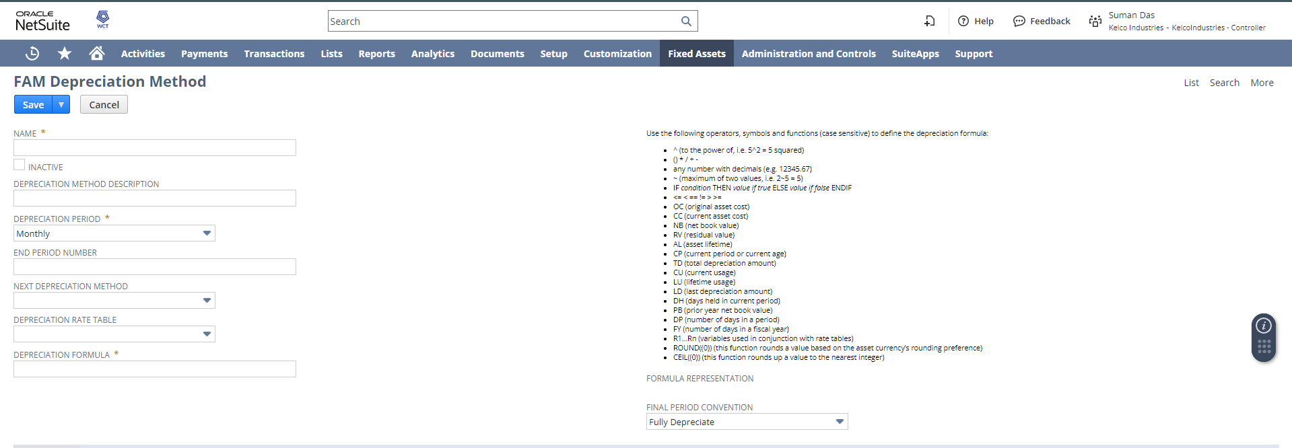

Creating Asset Type
Log in to NetSuite using the Controller role, and navigate to Fixed Assets-> Setup-> Asset Types-> New.
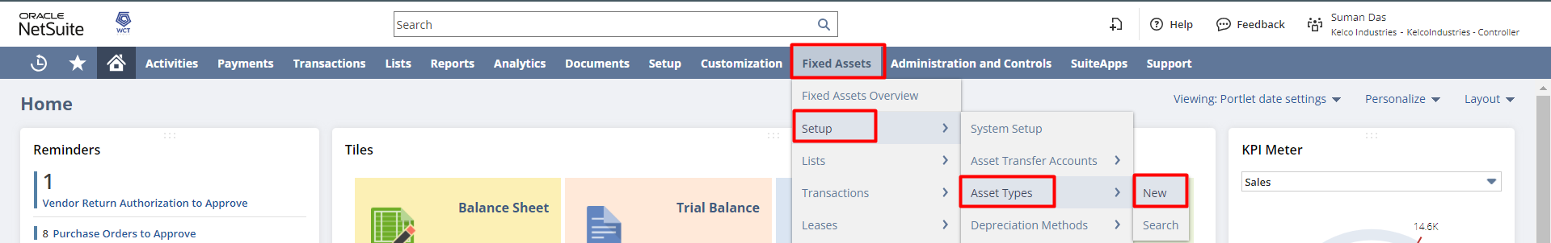
Enter the Name, Residual Percentage (Enter the percentage value of the original cost which the asset will be worth at the end of its lifetime),
Asset Lifetime (The expected lifetime of the asset, in multiples of the depreciation period (e.g. if depreciating monthly, enter lifetime in months), and
select the Accounting Method (Select the default depreciation method (formula) to use when creating assets of this type. This method will be used to calculate the values that will be entered into the accounting system).
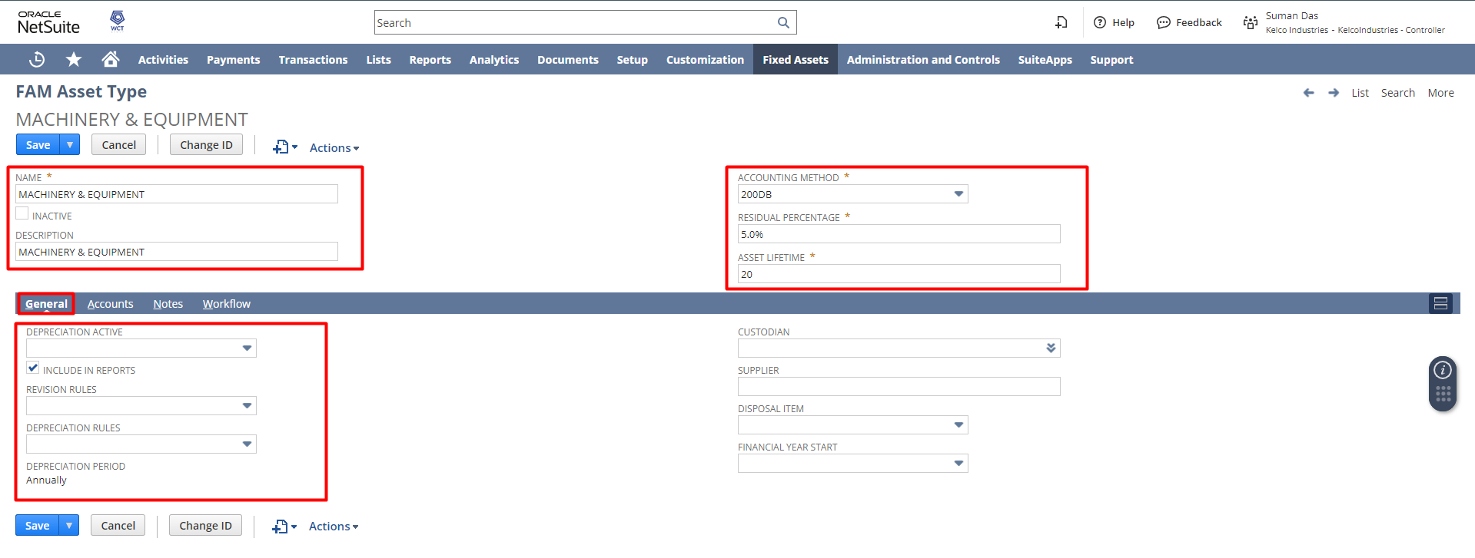

Under the General subtab, select the Depreciation Active:
Depreciation Active – Select from the following options:
- True — Select True to make this asset type active and include it in depreciation processing.
- False — Select False if you do not want to include this asset type in depreciation processing.
- On Project Completion — For assets related to a project, this option sets the assets to start depreciation when the project is completed.

Include in Reports – Check this box to include the asset type in the Asset Summary Report. By default, all assets are included in the report.

Revision Rules – Controls how revisions (revaluation) affect the asset. Select from the following options:
- Current Period — The depreciation of the asset to date is recalculated using the revised values, and the difference between the calculated depreciation and the previously posted depreciation is entered in the current period.
- Remaining Life — The revision only applies to the asset from this point forward, so it only affects future depreciation calculations.

Depreciation Rules – Select from the following options:
- Acquisition – Asset is depreciated in the same period when it is first made active.
- Disposal – The asset is depreciated in the final period of its lifetime.
- Pro-rata – Asset will depreciate in proportion to a partial month in both the acquisition and disposal period, based on a standardized 30-day month.

Depreciation Period – Select whether the asset will be depreciated monthly or annually.
Custodian – Select the default employee responsible for assets of this type.
Supplier – Enter the vendor that assets of this type are purchased from.
Disposal Item – Select a non-inventory item (for sale), to be used on the generated sales invoice, when the asset is disposed of (sold).
Financial Year Start - Select the first month of the financial year.

Under the Accounts subtab,
Asset Account – Select the main asset cost account (balance sheet). When proposing new assets, this is the account that will be searched for new transactions.
Depreciation Account – Select the account that will be tracking the accumulated depreciation (balance sheet).
Depreciation Charge Account – Select the expense account for the depreciation charges (period depreciation amount).
Write-Off Account – Select the account for the asset write-off expense.
Write Down Account – Select the account for the asset write-down expense.
Disposal Cost Account – Select the account for the asset disposal (sale) expenses.
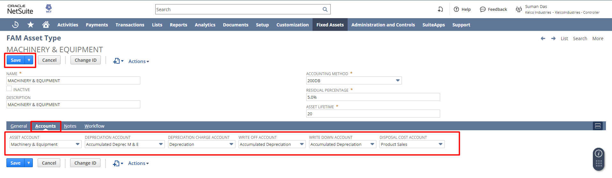

Purchase Order:

To create a Purchase Order, navigate to Transaction-> Purchase-> Enter Purchase Orders.

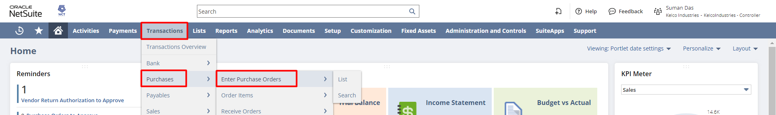

The purchase order form will open. Select the Vendor, Location, Department, Items and click on Save.
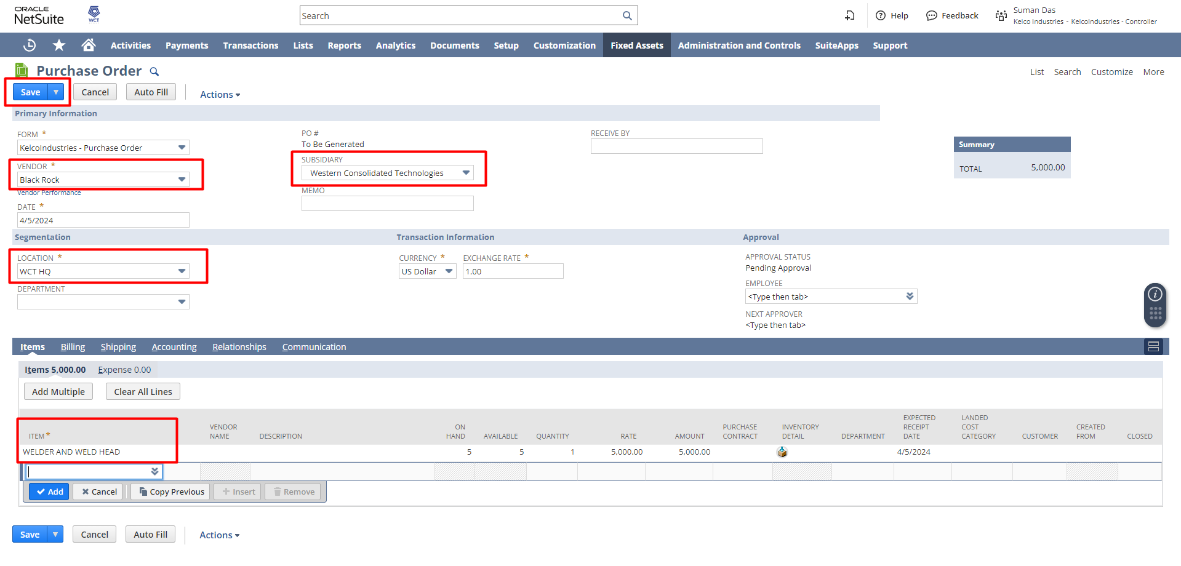
Once the Purchase Order is created, the Next Approver needs to Approve the PO for receiving the order.
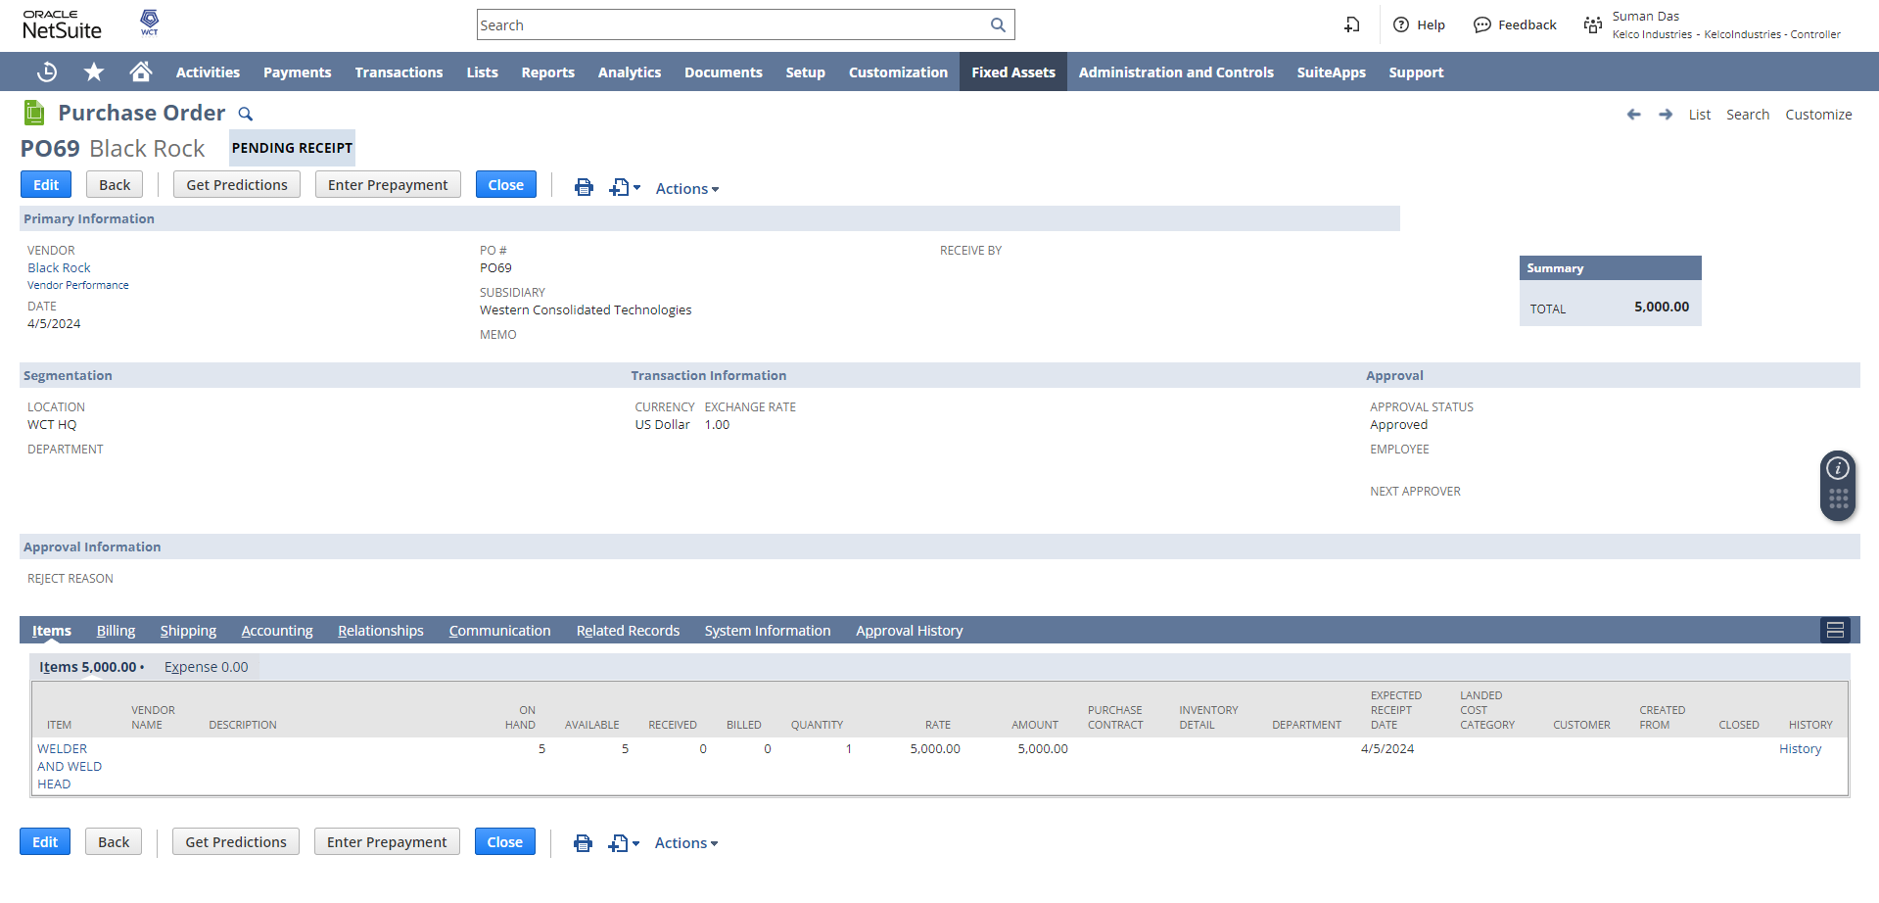

Receiving Purchase Order

Log in to NetSuite with the Warehouse Manager Role. From the Dashboard click on the Orders to Receive hyperlink, under the Reminders section.
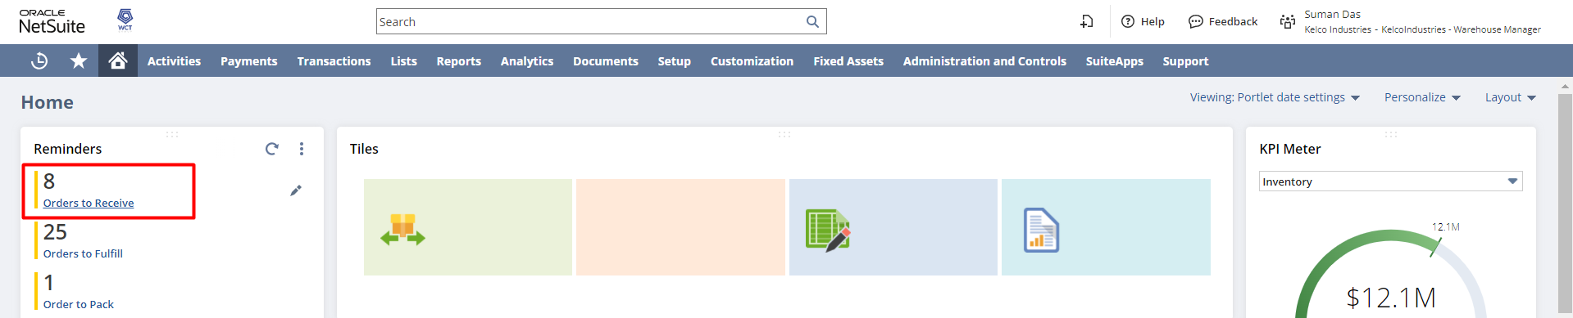

The list of purchase order will open which status is Pending Receipt. Click on the Receive hyperlink beside the previously created purchase order.
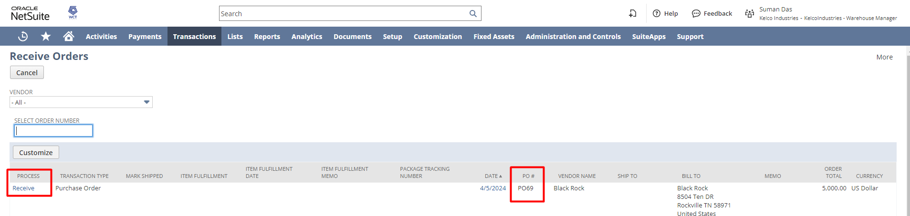

The Item Receipt form will open. Review the necessary details and click on Save.
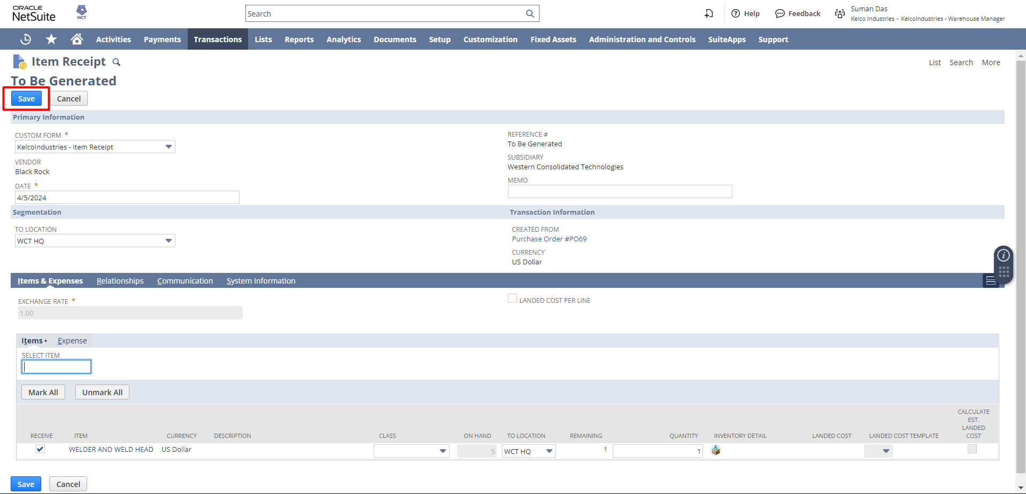

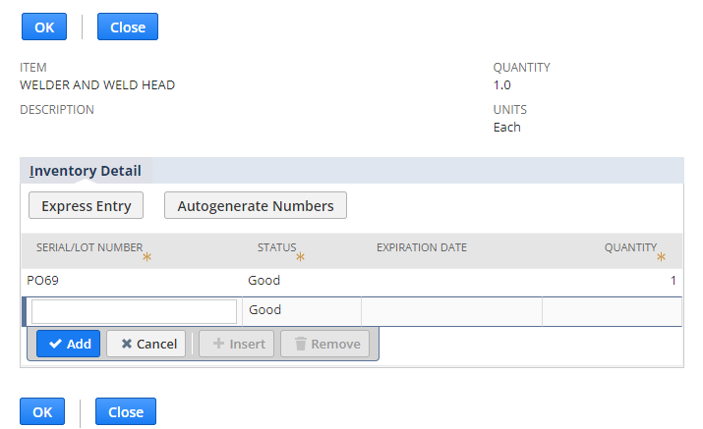

FAM Asset

There are several ways to create an FAM Asset.
Manual Entry: This will directly create the asset in the system.
Asset Creation: This will directly create the asset in the system without any approval steps.
Asset Proposal: This will propose the creation of assets in the system. It is step approval asset creation.
Manual Entry
To create an asset directly into the system, from the Controller role, navigate to Fixed Assets → Lists → Asset→ New
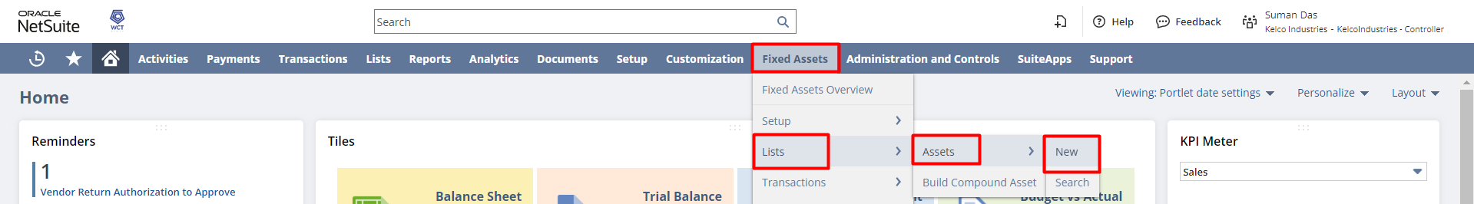

Enter the value of Name, Asset Type, Asset Original Cost, Residual Value, Depreciation Method, Asset Lifetime
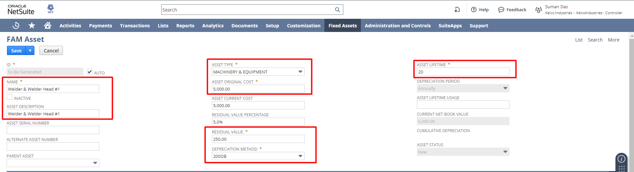
Under the general tab put Depreciation Start Date, End Date, Depreciation Rule, Financial Year Start and other related details.

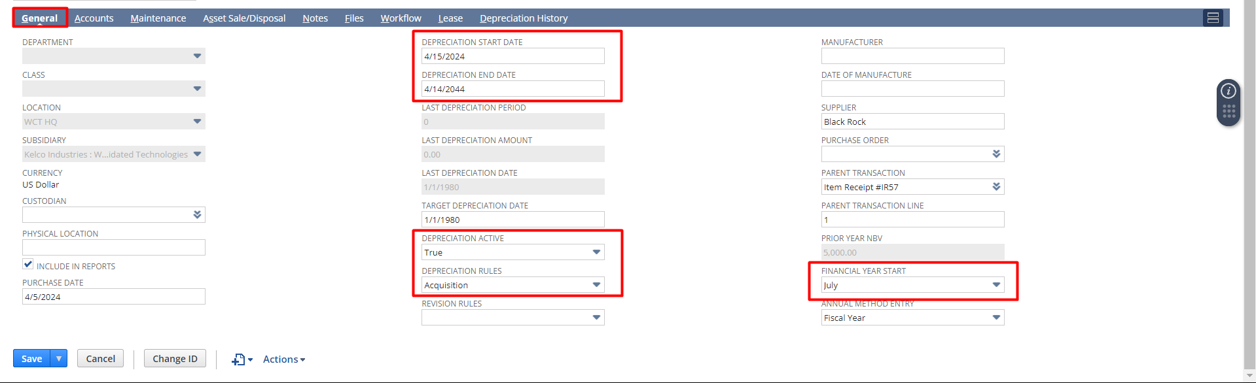
Under the accounts tab put the relevant accounts and click on Save.
Asset Creation
The user can enter fixed assets into the system by importing previous fixed asset data, manually creating asset records, or generating asset records from transaction records. Generating asset records from transaction records is typically done for newly acquired assets.
From the Controller role, navigate to Fixed Assets → Lists → Asset

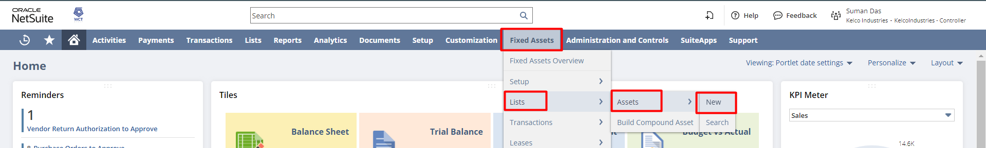
The Asset Creation form will open. Select the Start Date, End Date, Subsidiary. Under the Asset Types subtab select the Asset Type, click on Add. After that click on the Create Assets button
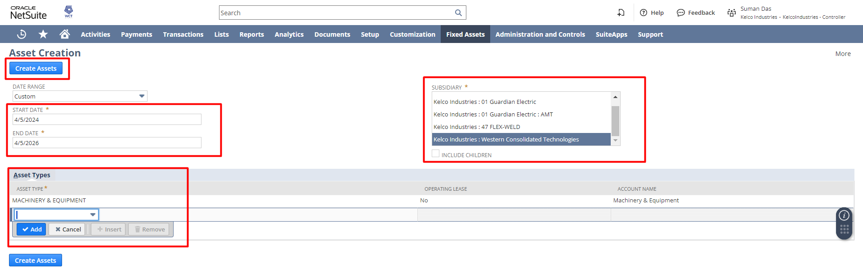
The FAM Process Status page will open. Click on the Refresh button to check the current status of the asset creation process.
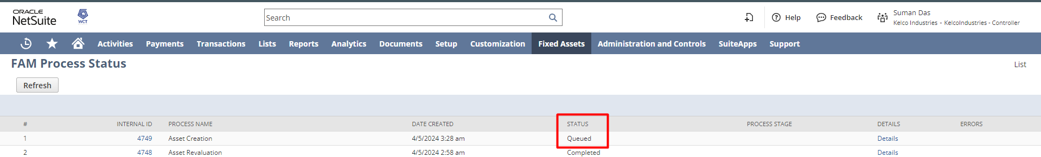
Notes: Assets can also be imported via CSV.
Asset Proposal
To create an Asset Proposal, log in to NetSuite with the Controller role and navigate to Fixed Assets-> Transactions-> Asset Proposal.

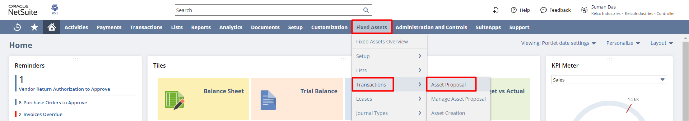
Select the Start Date, End Date, Subsidiary, and Asset Type. Click on the Propose New Asset button. Under the Asset Type subtab, select the Asset Type, and click on Add. Then click on Propose New Assets.
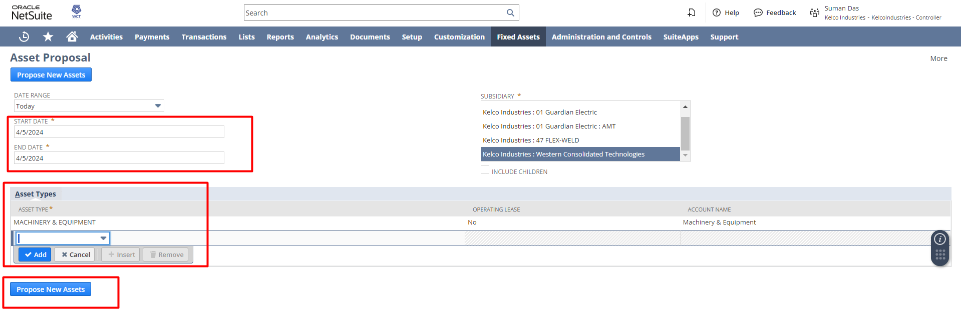
After that, the FAM Process Status page will open. Click on the Refresh button to see the Status of the proposed asset from Queued to Completed.

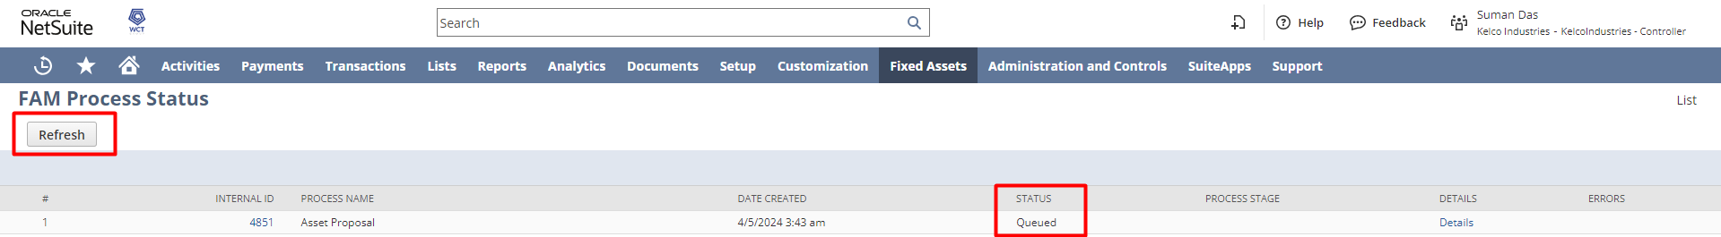
The status will change to Completed.
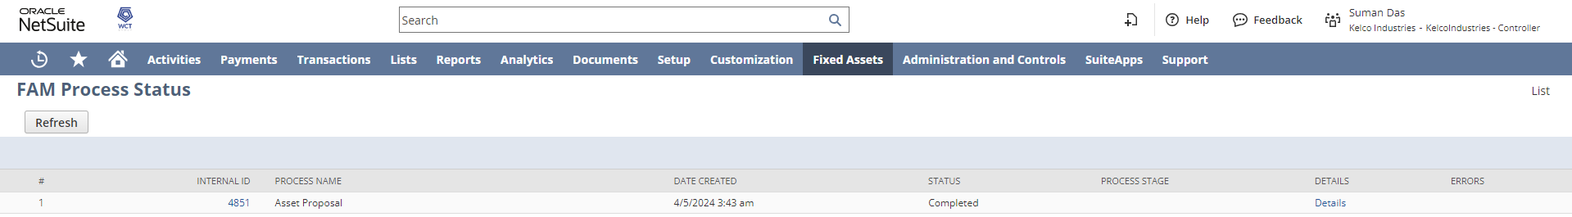

Manage Asset Proposal
In order to view the list of proposed asset or to manage the Asset Proposal, Navigate to Fixed Assets-> Transactions-> Manage Asset Proposal.
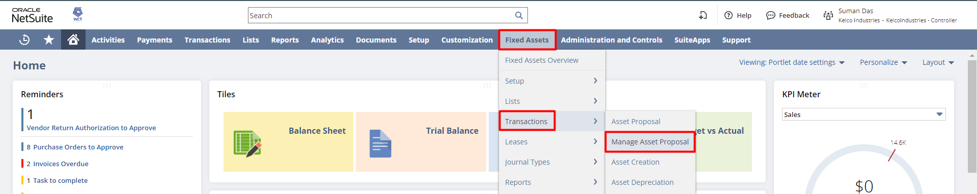
Check the checkbox for the Receipt for which the user wants to create the Asset. Click on the Generate Assets button.
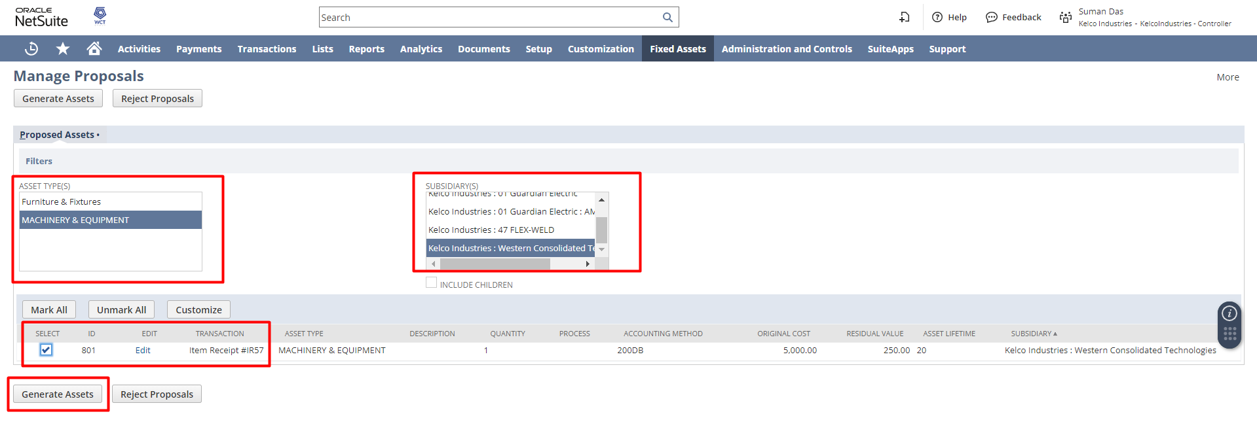

After clicking on the Generate Assets button a dialog box will open. Click OK to continue.
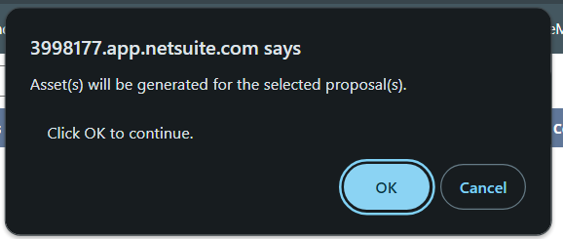
After that, the FAM Process Status page will open. Click on the Refresh button to check the current status of the asset generation process.

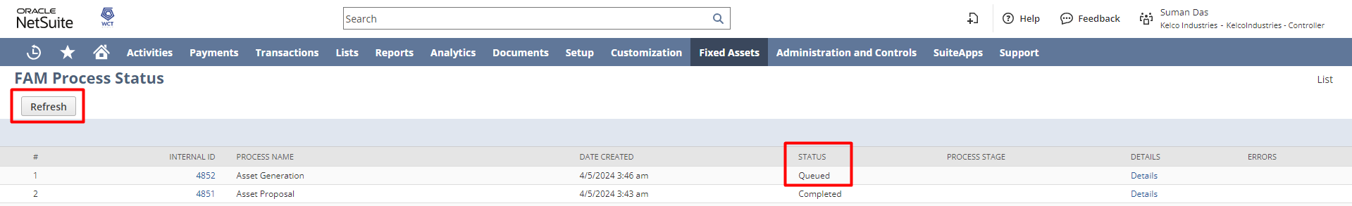
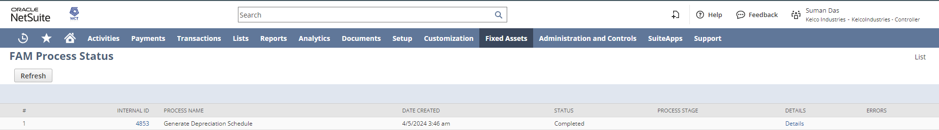

Asset List
Login to NetSuite with Controller role, navigate Fixed Assets → Lists → Asset.
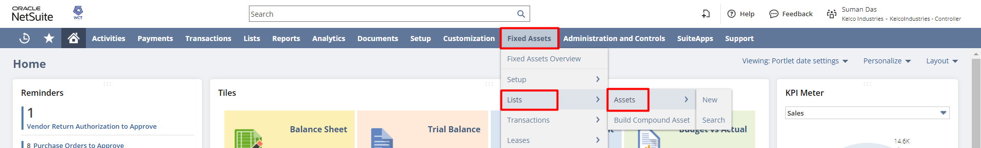
From the list Asset record, click on the VIEW hyperlink, to open the Asset record.
Also, the user can click on New FAM Asset to create a new Asset record.

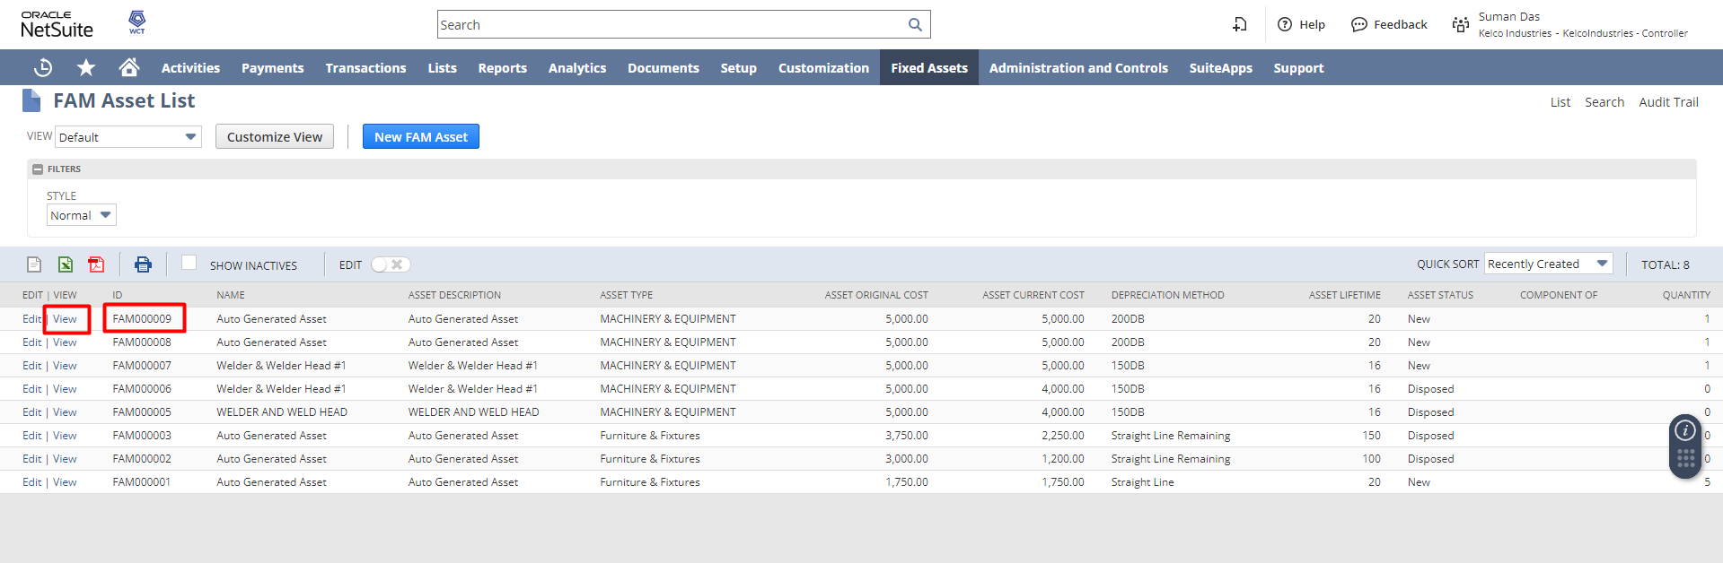
Click on the EDIT hyperlink, to edit the details (if required) & save the record.
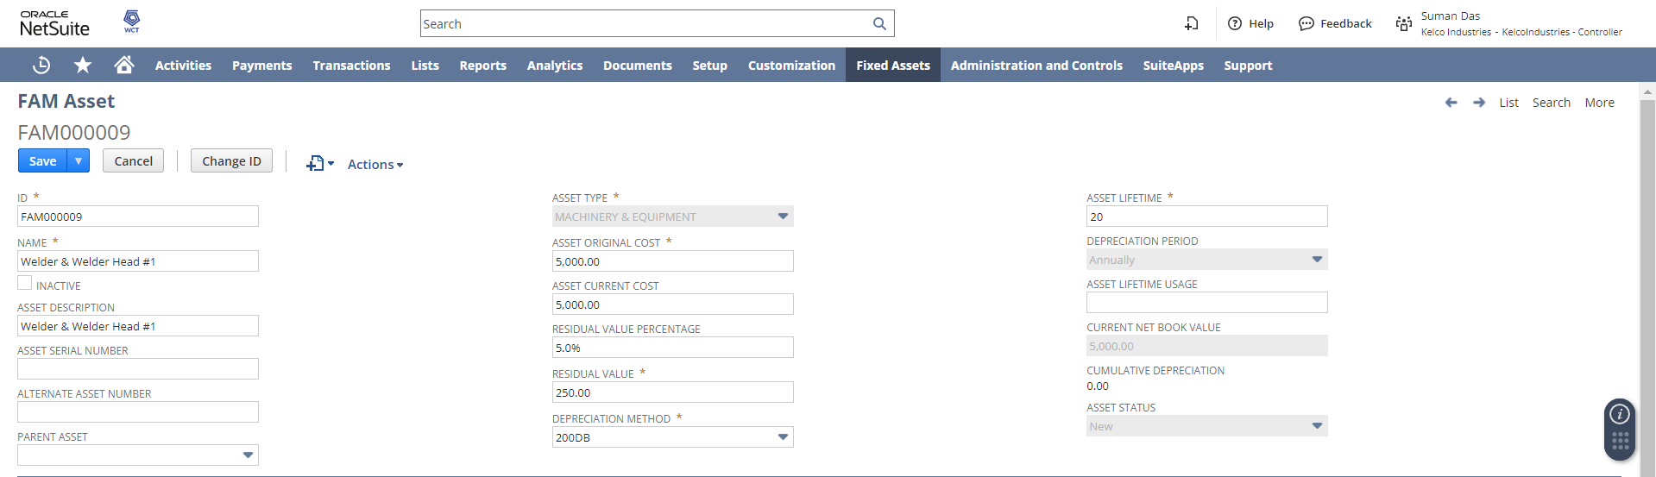

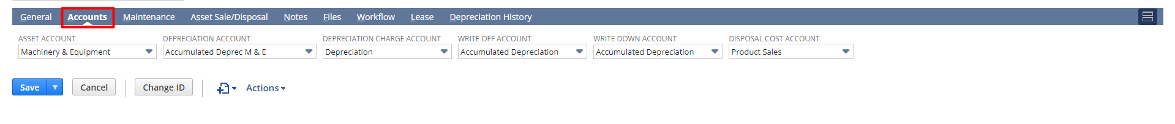
Under the Depreciation History subtab, click on the Depreciation Histories hyperlink to view the Depreciation History for that asset record.
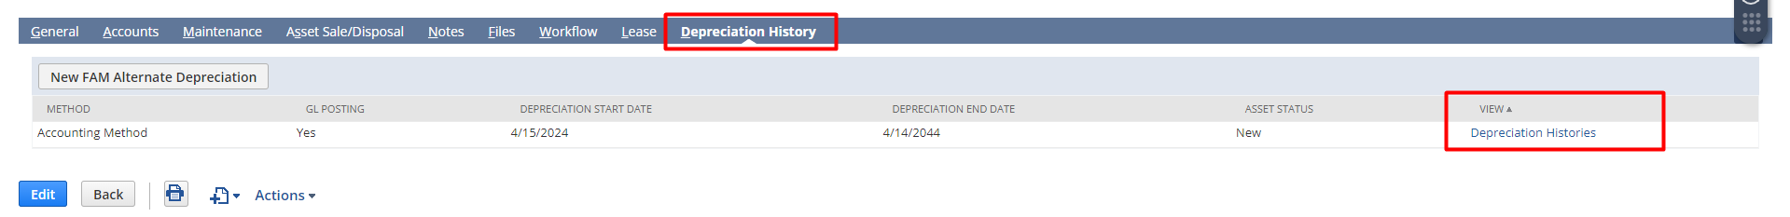
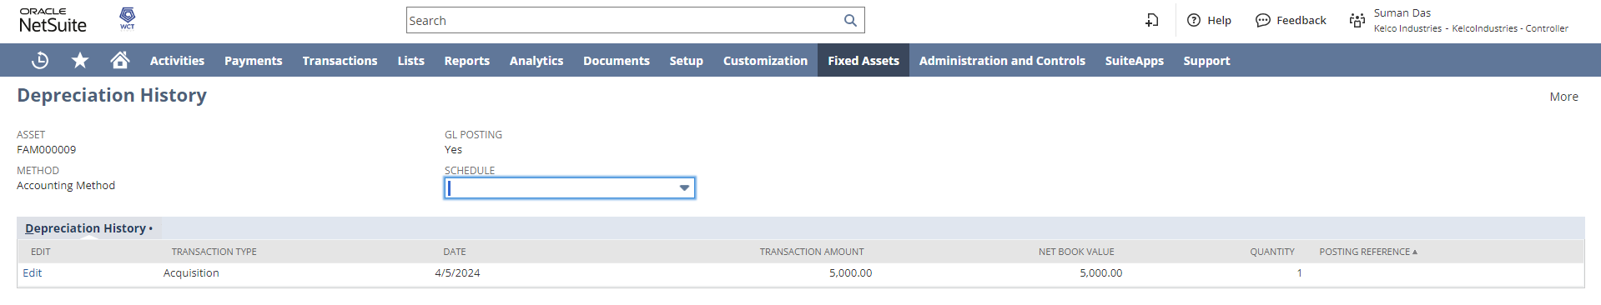
Asset Depreciation
The user can run Asset Depreciation to depreciate assets for the first time or to depreciate an asset following a revision of the depreciation method or period.

Asset depreciation can be performed periodically for a single asset type or for several asset types. This procedure is run to depreciate assets for the next period. It will decide which assets require depreciation by checking the depreciation start date, last depreciation period, and depreciation rules. When posting the depreciation values, the system will create a batch of GL journal entries.

An asset will depreciate for each period set on the depreciation method. An asset will depreciate for each of its period intervals up to the date entered on the Depreciate Assets page.
For example, if an asset has a monthly depreciation period, and its last depreciation is in January, a depreciation run for June will cause a depreciation to happen for February, March, April, May, and June.

Log in to NetSuite with Controller role, navigate to Fixed Assets → Transactions → Asset Depreciation.
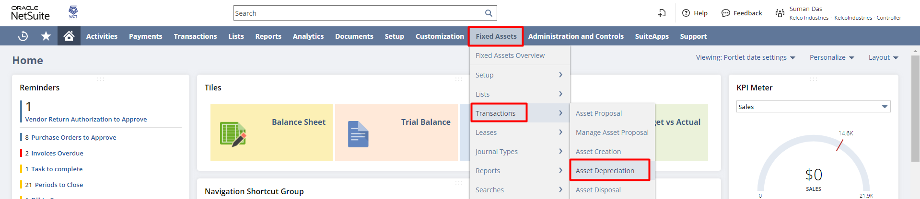

Select the Asset Type, Subsidiary & enter a Depreciation Date up to which assets will be depreciated.

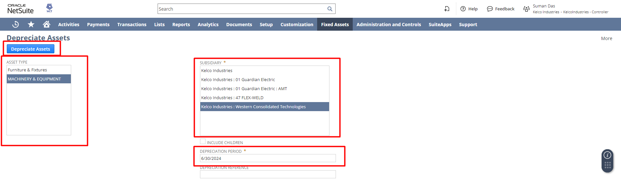
again the FAM Process Status page will open
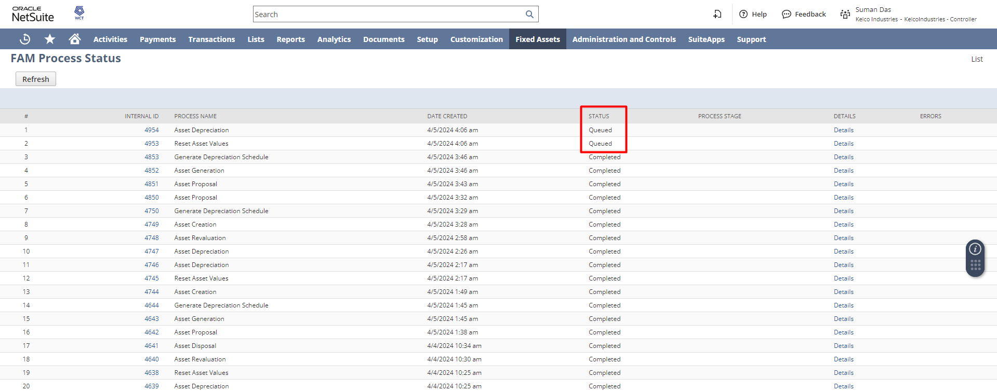

When it’s get completed, go to Asset again and you can see the Current Net Value is decreased.
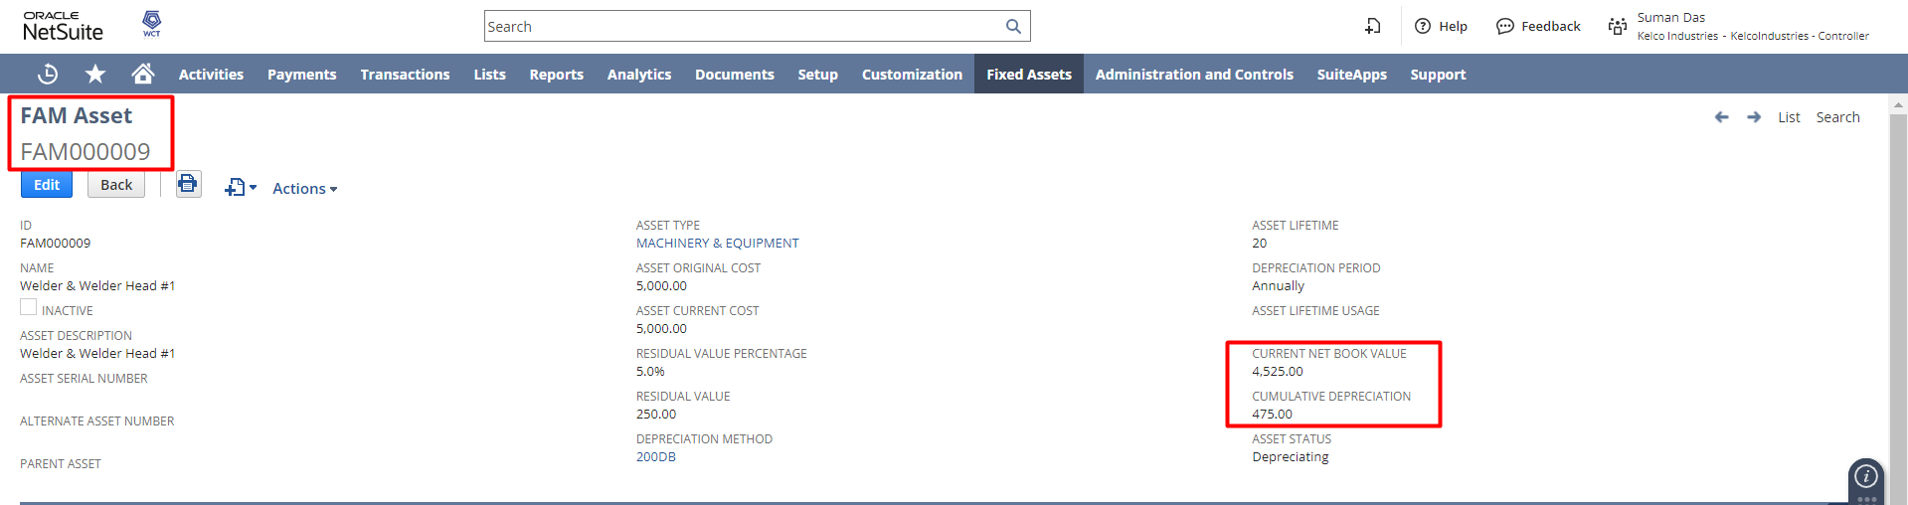
if you open depreciation history, you can see a Journal entry has been entered to depreciate the amount.
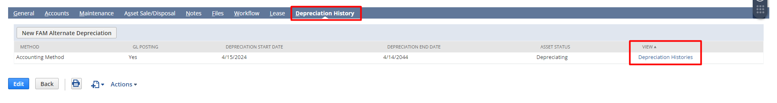
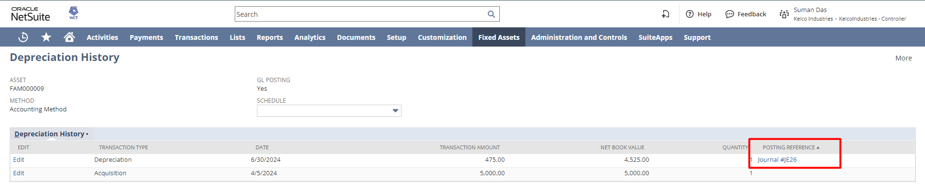
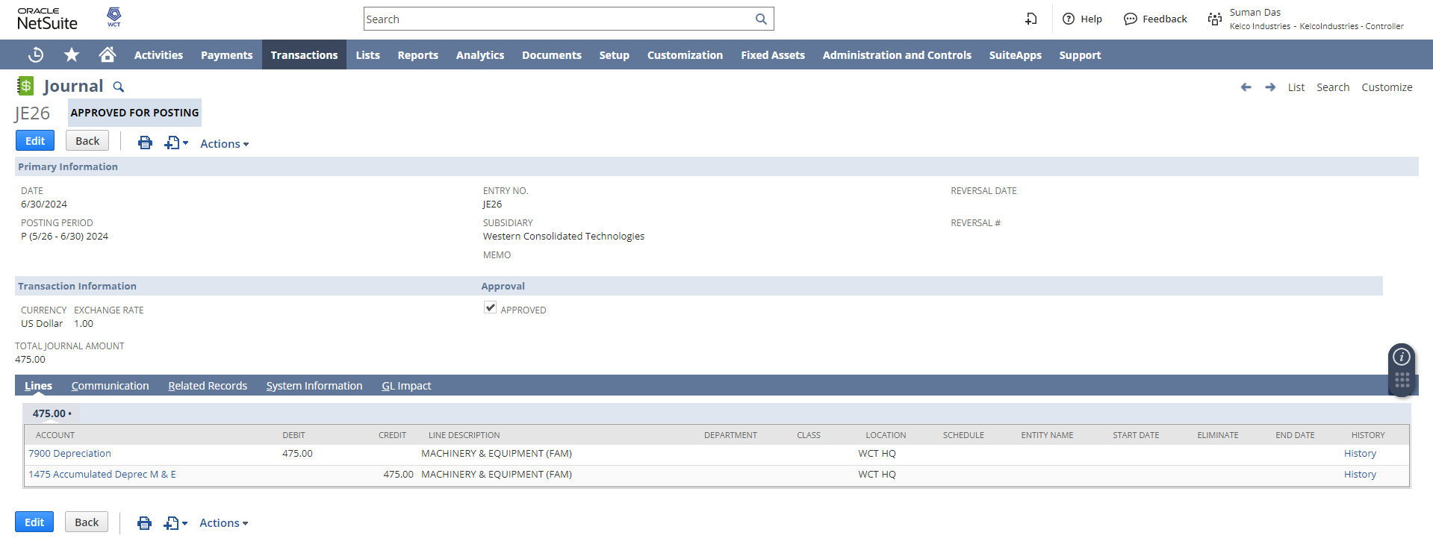
Asset Revaluation

The Asset Revaluation feature enables you to write down or revaluate an asset. Log in to NetSuite with Controller role, navigate to Fixed Assets → Transactions → Asset Revaluation.
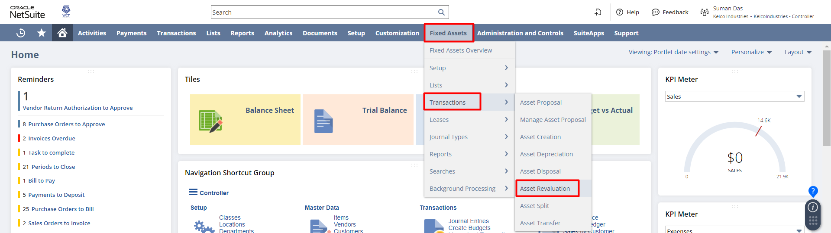

Select Asset ID/Name, Accounting Books, Write-down %, Transaction Date, Write-down Amount , Adjusted Residual Value, Adjusted Lifetime , Adjusted Depreciation Method and click on Process Revaluation.
Click Calculate to compute the write-down amount based on the write-down percentage.
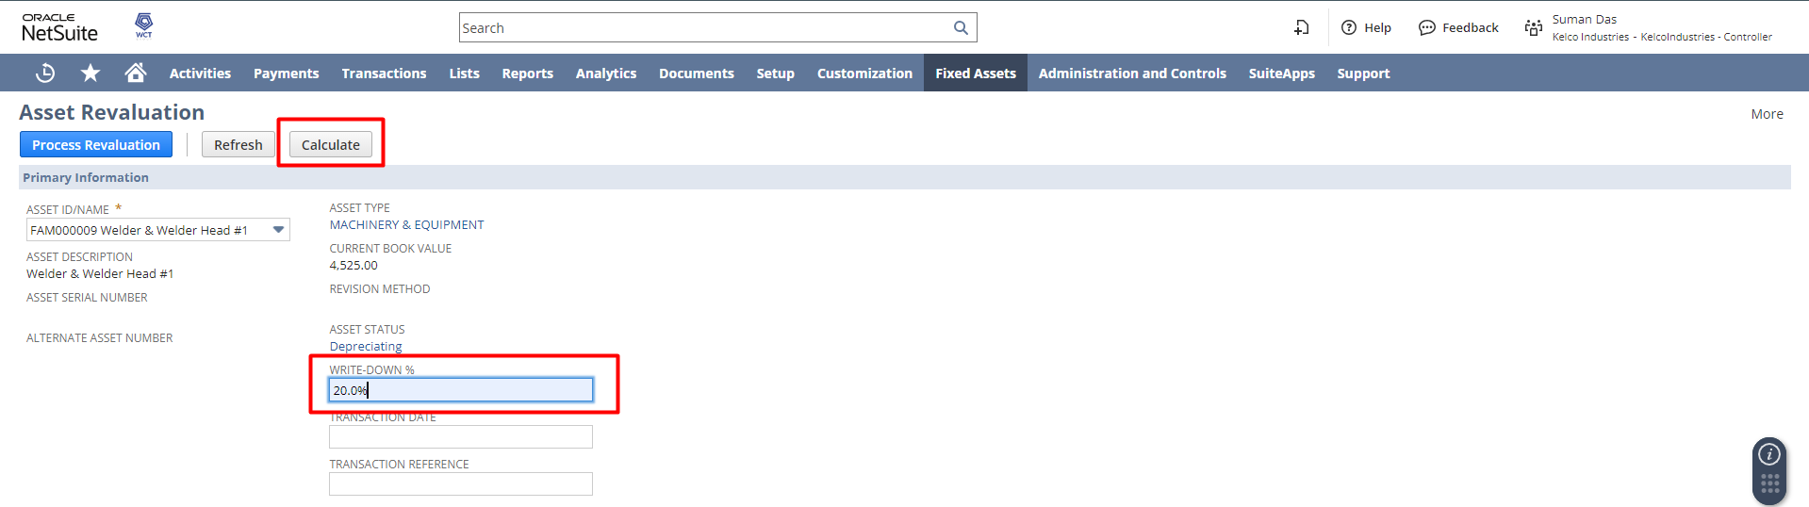
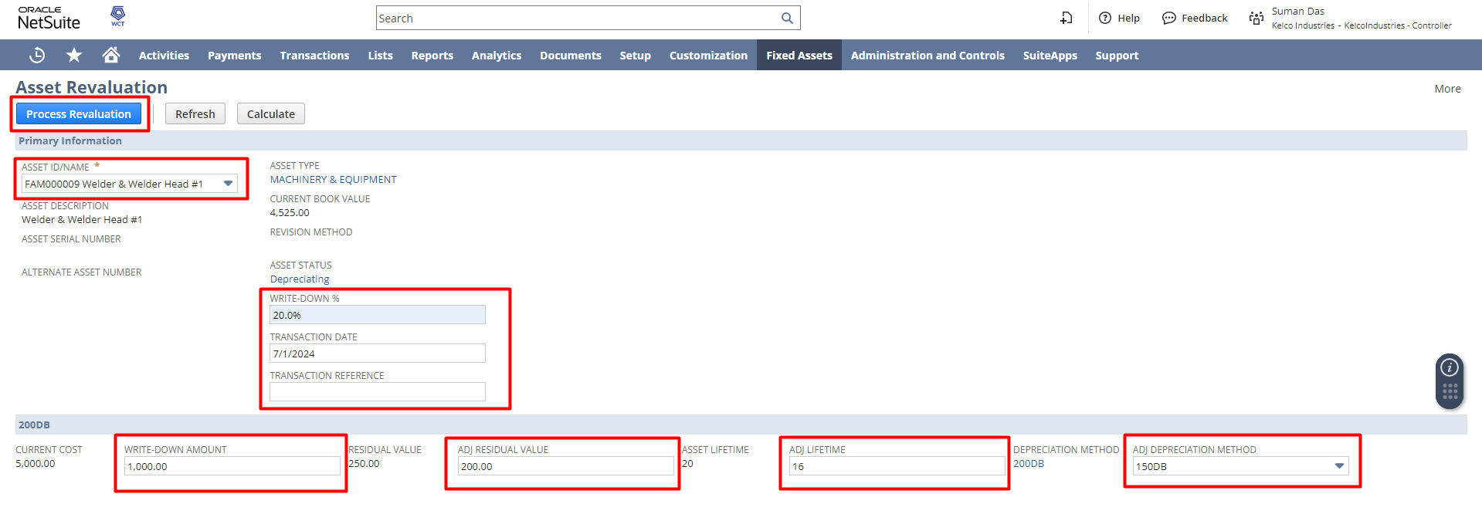

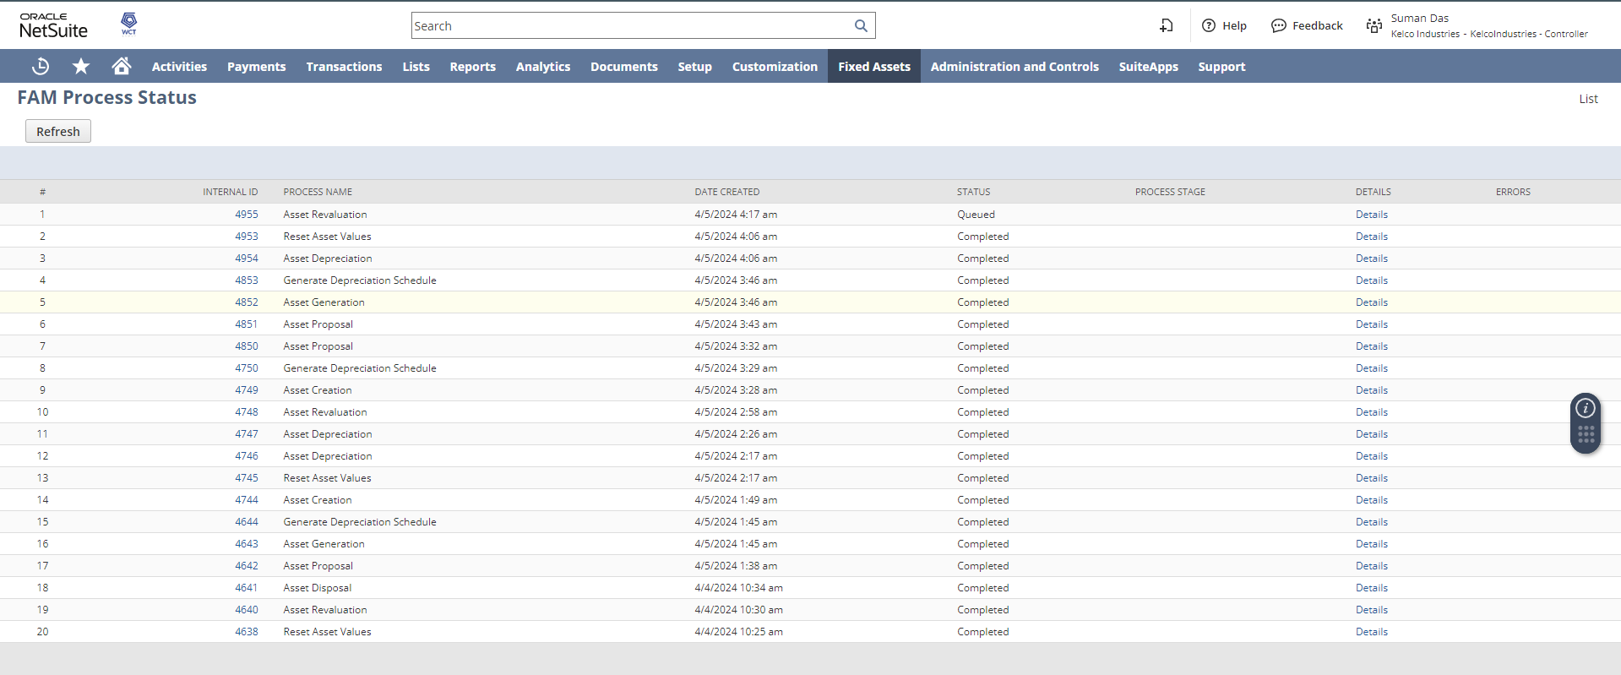
after the status get completed go back to the Asset and you can see the Current Net Book Value is reduce.
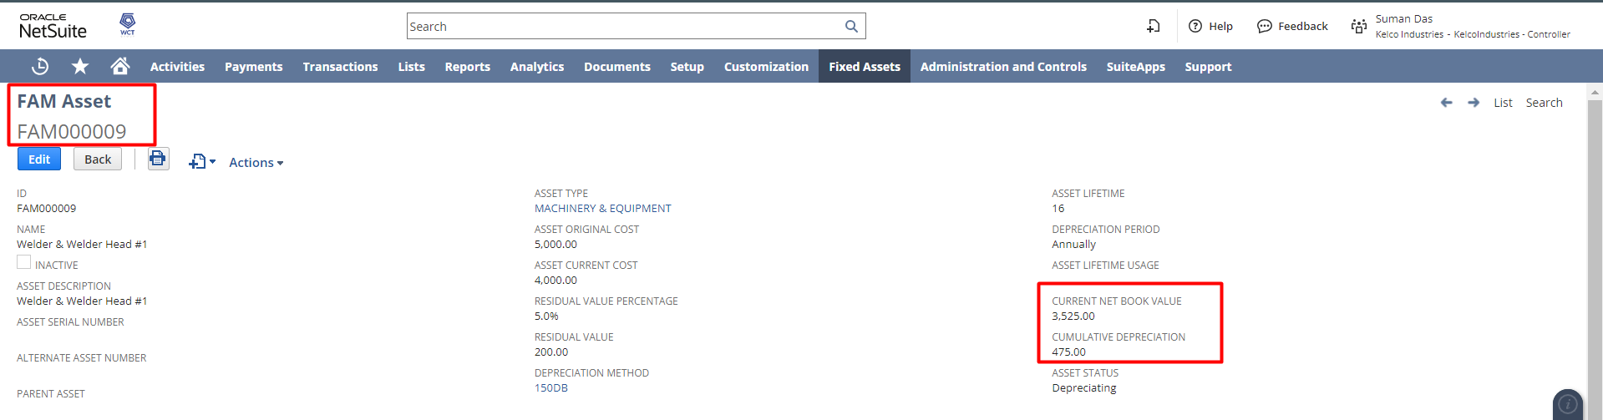
and if you open depreciation history again, you can see a Write down Journal entry that has been posted.
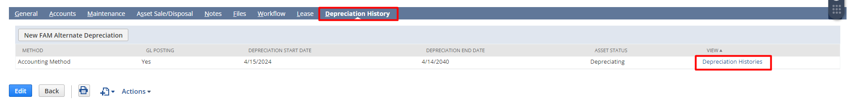
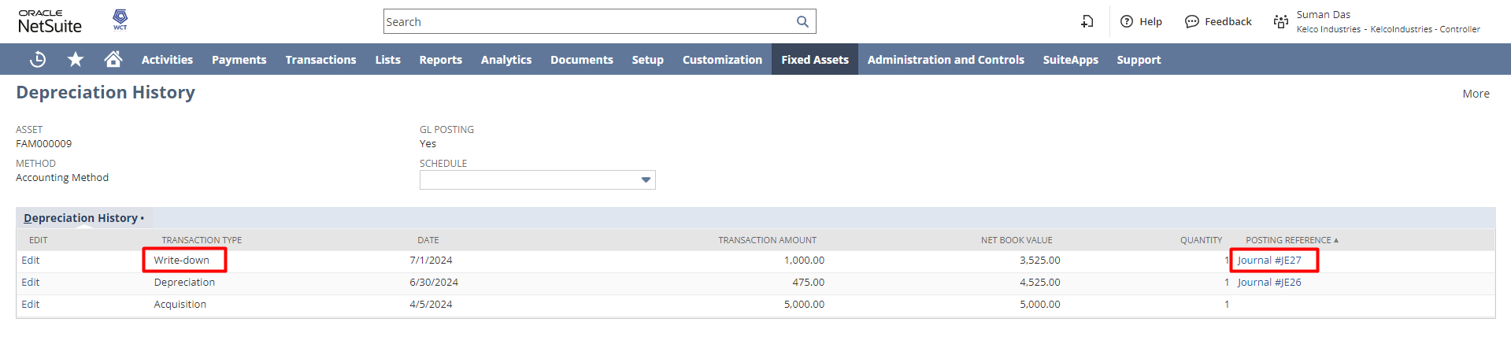
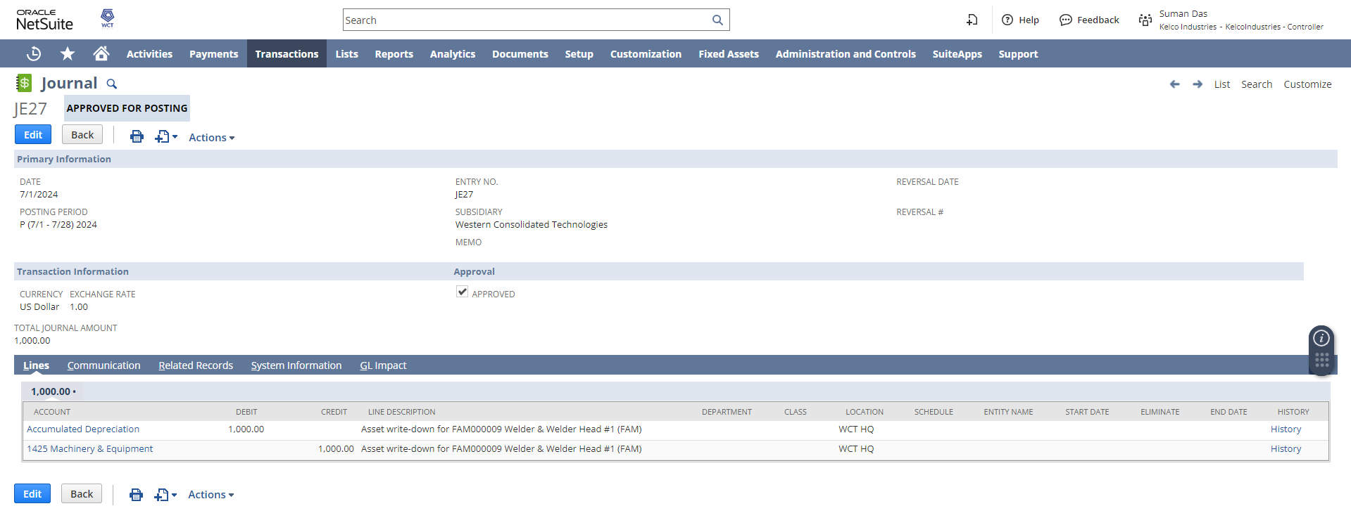
Asset Disposal
When a fixed asset is disposed during, or at the end of its useful economic life, an adjustment needs to be made to the depreciation provision account so that the account balance represents only the accumulated depreciation to date on fixed assets held at that point in time.
To access the Asset Sale/Disposal page, Log in to NetSuite with Controller role, navigate to Fixed Assets → Transactions → Asset Disposal.
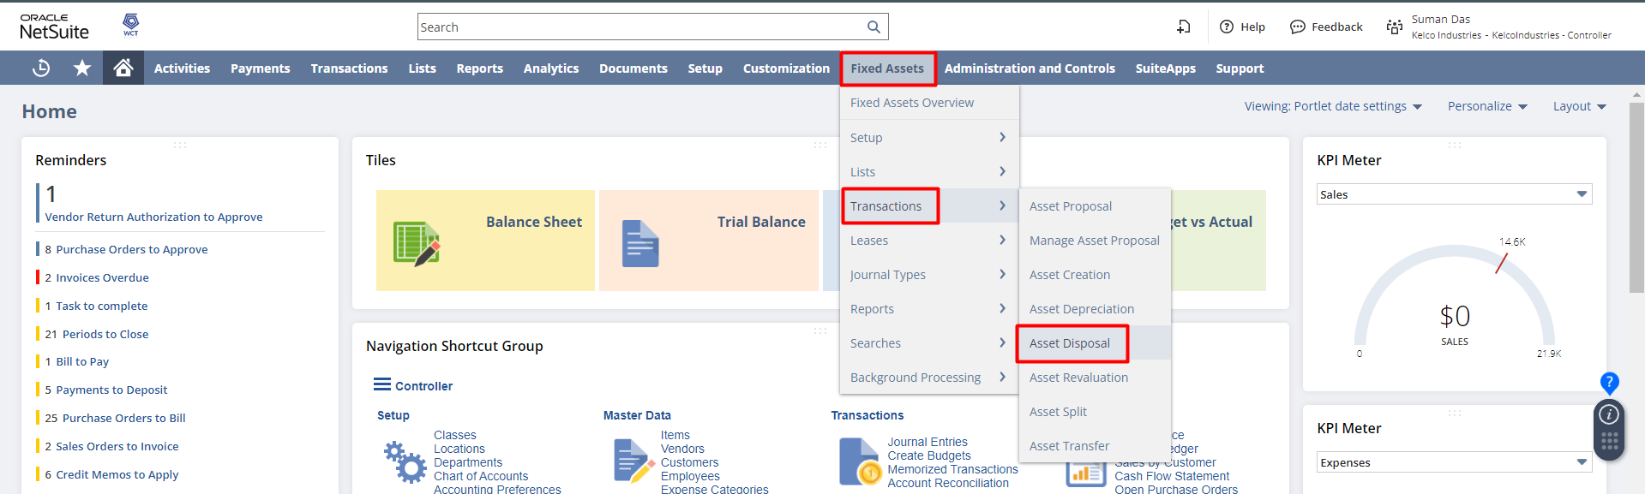
enter Disposal Type, Disposal Date, Customer, Sale Item and On the Disposal Details field group, provide values for Asset ID/Name, Quantity To Dispose, Sale Amount, Location and click on Save.
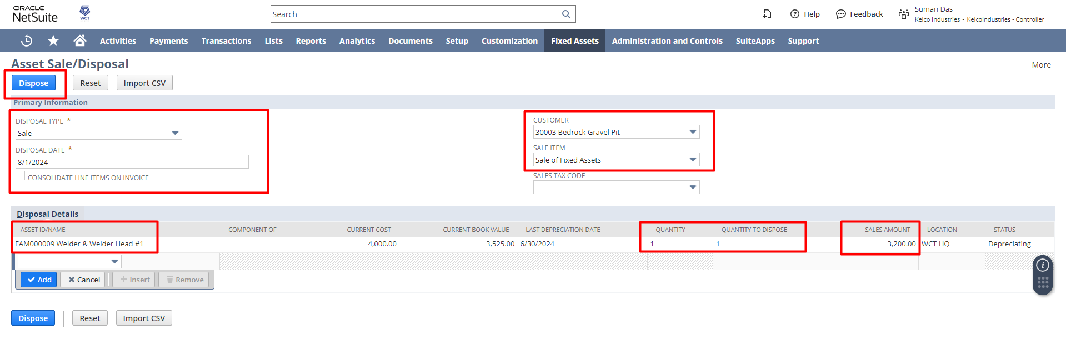
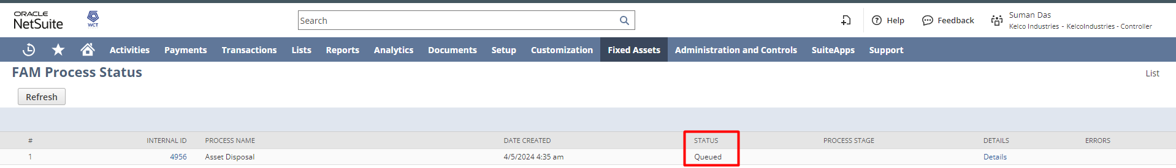
after it’s get completed open the asset again you can see the Asset Status set to Dispose and the Net Book Value set to 0 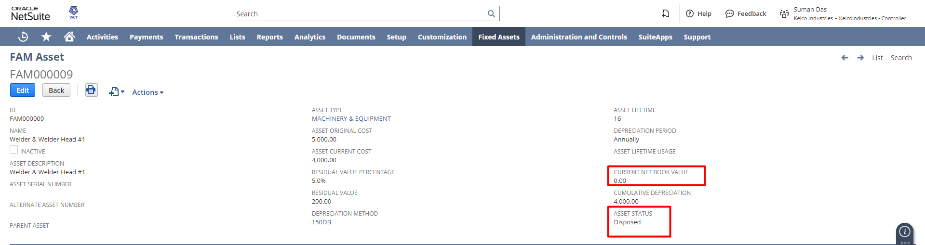
and once the asset has been disposed, you can see the details of that under the Asset Sale/Disposal
tab
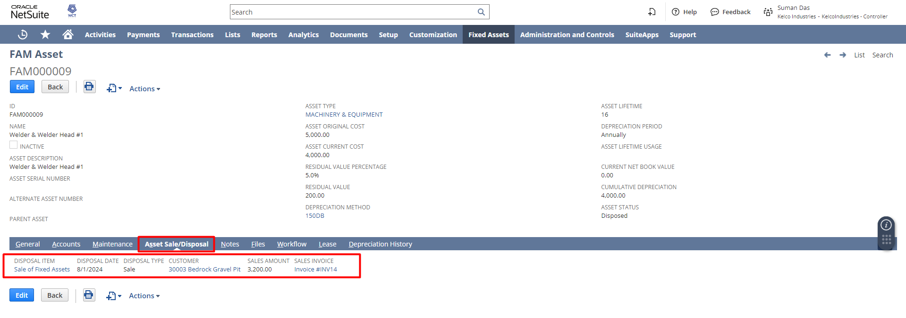
and also if you open the depreciation history, you can see the Journal entries that has been posted.
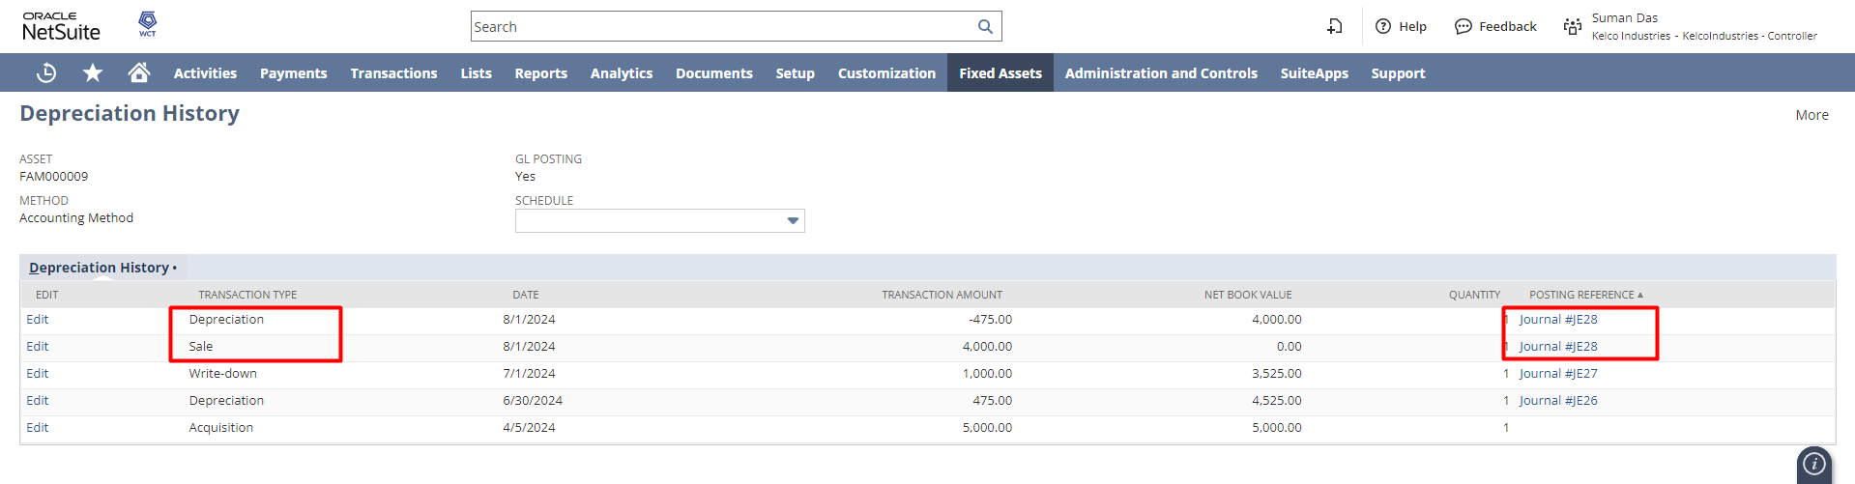

Signature: _______________________
Date: ______________________

Disclaimer:
Upon signing off on the document, you are confirming that the process has been set up per the SOW within NetSuite per your business’s needs. Any changes or modifications requested after sign-off will need to be a “change request” at an additional fee.

***PLEASE ensure that you have logged into NetSuite and tested the process before signing off on the setup. Paapri requires sign-off on this document before moving forward with any additional design meetings.

